AFTER PLAYING A SOLD OUT UK TOUR WITH JP COOPER,
LUCAS WATT RETURNS WITH NEW SINGLE ‘I DON’T FEEL FINE’
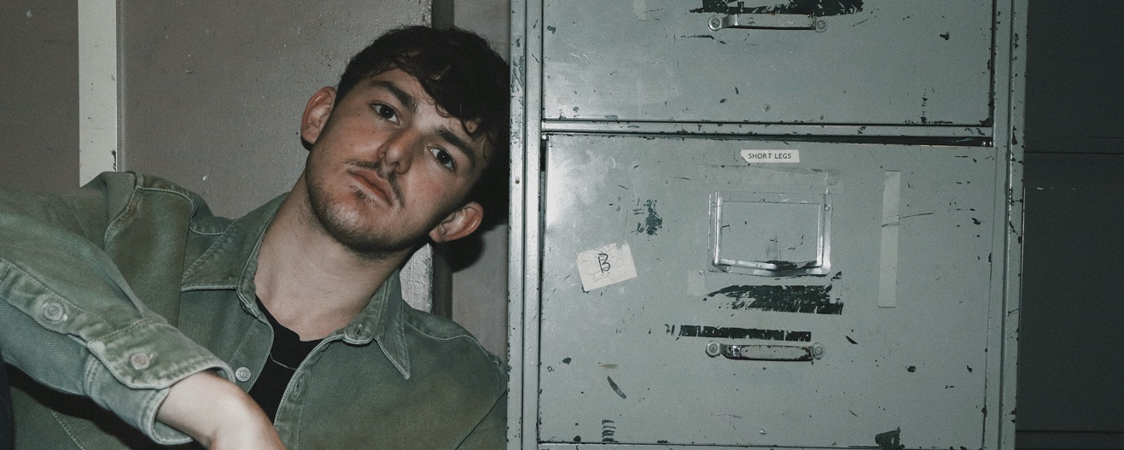

Having already toured with JP Cooper, supported the likes of Larkins, Shed Seven and Giant Rooks as well as receiving extensive airplay on BBC Introducing, Leeds indie-pop artist returns bigger and better than ever with new single ‘I Don’t Feel Fine’, dropping April 3rd.

Stream ‘I Don’t Feel Fine’ here: https://bit.ly/2Tz11B7

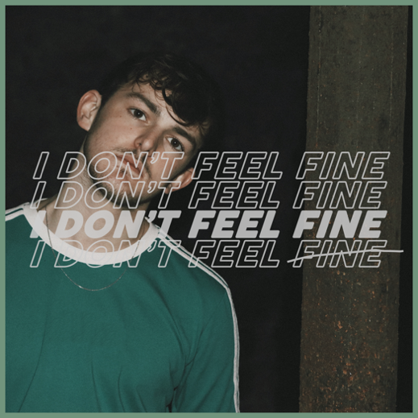
Lucas Watt takes a wide range of influences from artists such as Sam Fender, Sundara Karma, Tom Grennan and The Night Café. After being overwhelmed by the response to his previous single, Watt was determined to write a song that connected to an even wider audience by singing about people’s frustrations with the monotony of everyday life and feeling like you’re ‘stuck on repeat’. Lucas describes ‘I Don’t Feel Fine’ as “an anthem for the masses that loudly shouts about a common feeling of being caught in routine”.
"Oh my god, this is amazing! I really dig it. Lots of soul, lots of sentiment, what's not to like?" - Jericho keys (BBC Introducing)
“An absolutely fabulous lyricist with an even more fabulous voice. I don’t go a day without listening to it.” - Let’s Talk Music Blog

INSTAGRAM | SPOTIFY | FACEBOOK | TWITTER
LUCASWATT.CO.UK

